VIT BHOPAL UNIVERSITY
A PROJECT REPORT ON
PERSONAL FINANCE ANALYZER
Submitted to
Dr. Pavithra
Submitted by
Navya Mannan
Registration No.: 25BCE10972
1. Introduction
1.1 Project Context
The Personal Finance Analyzer is a foundational utility designed to bring clarity to personal money management. Developed as a Command Line Interface (CLI) application in Python, its purpose is to provide users with an efficient, straightforward tool for tracking expenditures and transforming raw transactional data into meaningful financial insights.
1.2 Objective
The primary objective of this project is to create a robust system capable of:
- Securely recording expenses with date, amount, and category details.
- Validating all user inputs to maintain high data quality.
- Generating summaries (overall and monthly) for financial analysis.
- Offering visual data representation using standard chart types.

2. System Architecture and Implementation
2.1 Technology Stack
The project relies on standard Python libraries:
- Python: Core programming language.
- csv: Used for file input/output and data persistence in the expenses.csv file.
- datetime: Handles all date parsing, validation, and filtering for monthly reports.
- matplotlib: The core visualization library for generating charts.

2.2 Core Functions
- The application is structured into the following key modules:
Function | Description
add_expense() | Handles the data entry process, including looping for re-entry on invalid inputs (date, amount, category). It writes the validated data to the CSV file.
view_expense() | Retrieves all records from the CSV file and presents them in a neatly formatted, readable table in the console.
summary() | Calculates the total expenditure and breaks down the spending by predefined categories (Food, Transport, Bills, etc.).
monthly_summary() | A specialized function that parses dates to isolate and summarize expenses only for a specific month and year requested by the user.
show_charts() | Processes the total category data and renders two visual charts for immediate understanding.

2.3 Data Handling and Validation
- The functions parse_date(date_str) and parse_amount(amt) are critical for data integrity. They ensure that dates strictly follow the YYYY-MM-DD format and that the amounts are valid, positive floating-point numbers.

3. Financial Visualization
The integration of matplotlib provides an essential dimension to the analysis, moving beyond simple numerical tables to graphical representation.
3.1 Bar Chart Analysis
The bar chart provides an absolute comparison of spending. Categories are displayed on the X-axis, and the corresponding amount spent is shown on the Y-axis. This visually highlights the top spending areas in terms of absolute money spent.
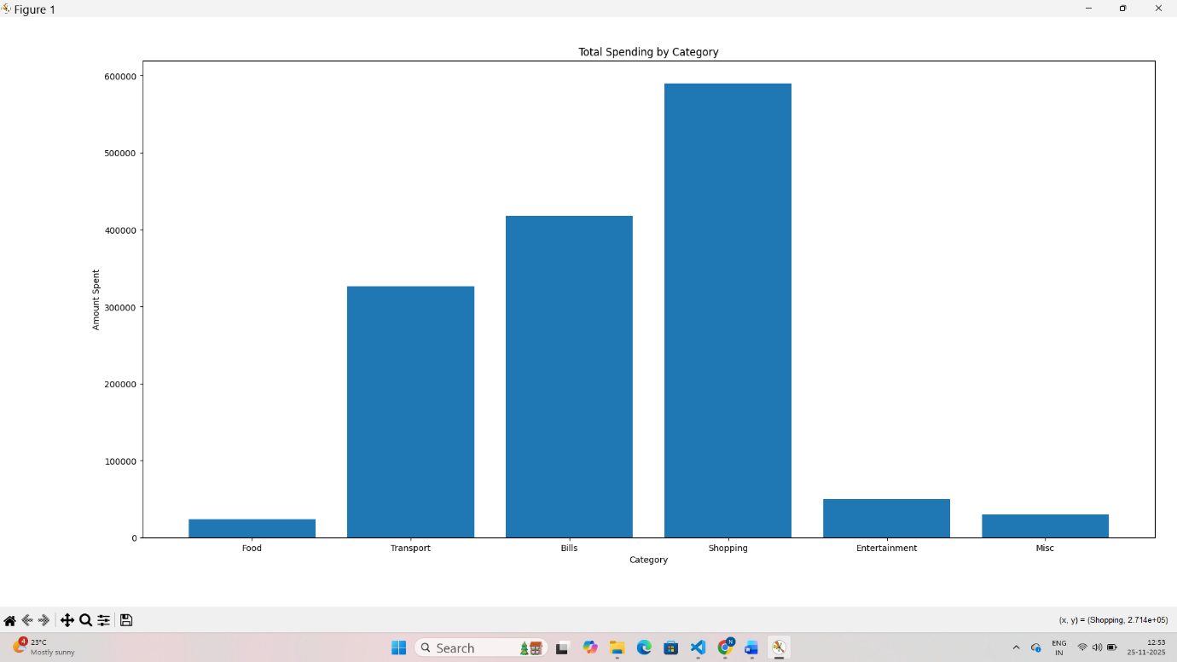
3.2 Pie Chart Analysis
The pie chart focuses on proportional distribution. It represents the percentage share of each category relative to the total expenditure. This helps the user understand how their budget is divided, quickly identifying which area consumes the largest proportion of their income. 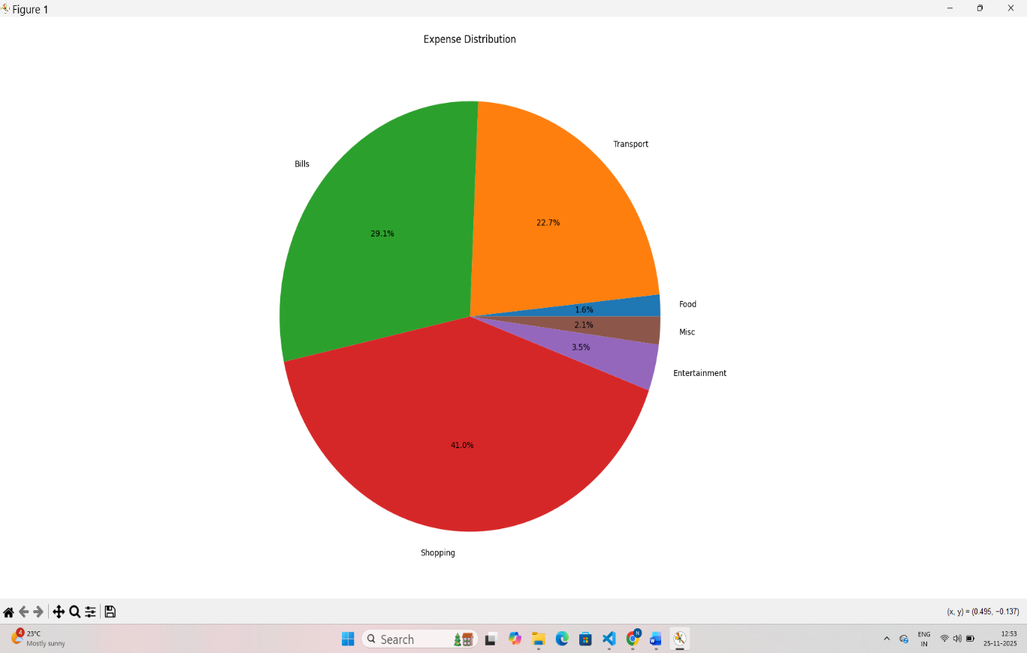

4. Conclusion and Future Scope
The Finance Analyzer project, as submitted, is a complete and functional expense tracking utility. It successfully demonstrates skills in Python programming, file handling (csv), data validation, and graphical representation (matplotlib).
4.1 Potential Enhancements
For future development, the project could be expanded to include:
- Budget Setting: Allow users to set monthly limits per category and flag when limits are reached.
- Data Modification: Implement features to edit or delete existing expense records.
- GUI Development: Migrate the CLI interface to a graphical user interface using libraries like Tkinter or PyQt for improved user experience.

## OUTPUT SCREENSHOTS ##
